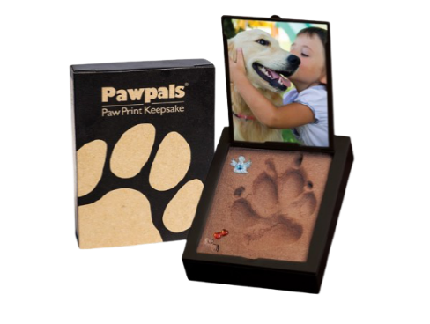**Pawpals Paw Print Kit**

Our pawpals kit is unlike any clay imprint because it is simply one step with an instant result. It also comes with an area to place your pet's photo. Please note this is separate to ashes and doesn’t include your pet’s ashes please see below for options for the return of your pet's ashes.

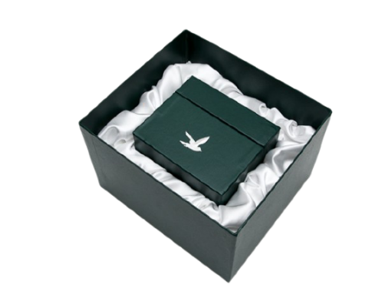**Pet Scatter Boxes and Tubes**

**Deluxe Scatter Box**

The Deluxe Scatter Box comes with a contemporary styled inner box, ideal for you to inter or scatter the ashes of your companion.

Cat/Rabbit £TBA please quote V55

Dog £TBA please quote V55

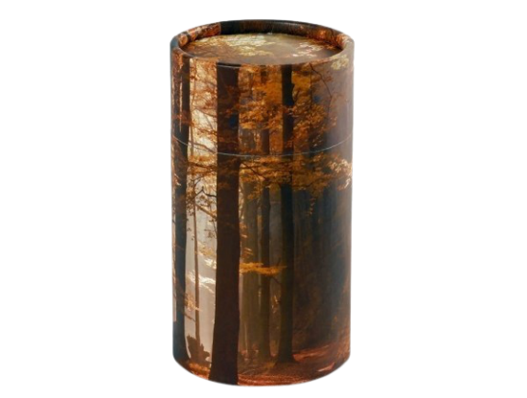**Woodland Scatter Tube**

Scatter Tubes are suitable for interment, ashes scattering or as keepsakes. Created from over 90% recycled materials and are biodegradable, making them a very environmentally friendly choice.

Cat/Rabbit £TBA please quote V02

Dog £TBA please quote V02

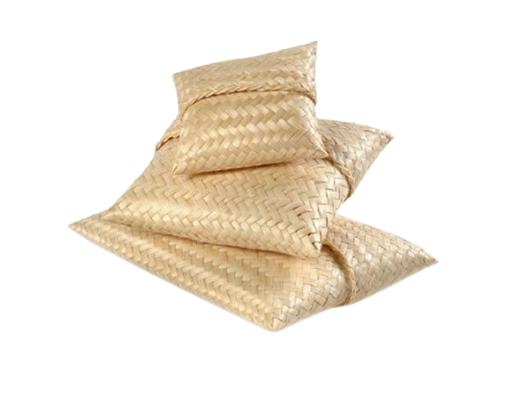

**Scatter Pouch**

Scatter Pouches are hand woven in natural bamboo, an eco-friendly and totally biodegradable containerof for the burial or scattering of pet ashes.

Cat/ Rabbit £TBA please quote V03

Dog £TBA please quote V03

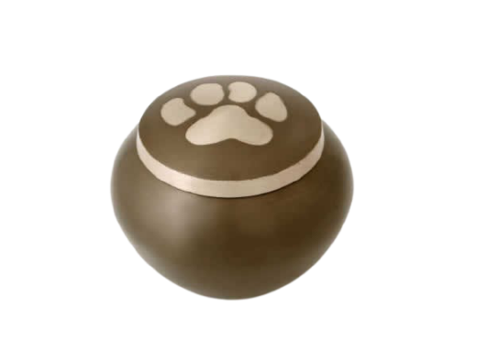**Pet Urns**

**Slate Odyssey**

A beautiful simple grey urn with one silver paw print on.

Cat/Rabbit £TBA please quote V08

Dog £TBA please quote V08

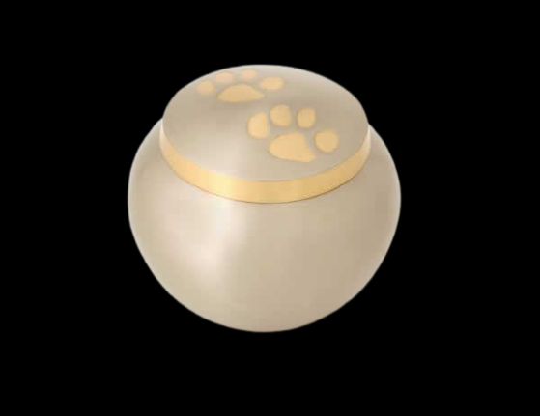

**Pewter Odyssey Urn**

The colour of this urn is silver with goldpaw prints on.

Cat/ Rabbit £TBA please quote V07

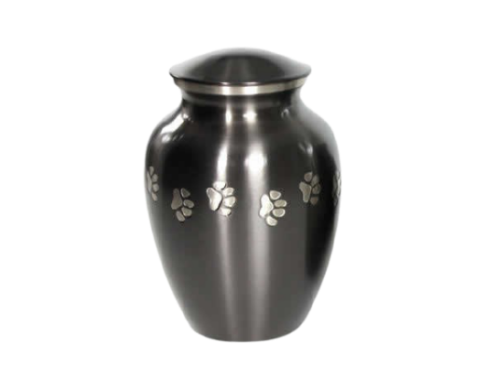Dog £TBA please quote V07.

**Classic Urns**

This classic urn is engraved with paw prints and has a slate finish.

Cat £TBA please quote V11

Dog £TBA please quote V11

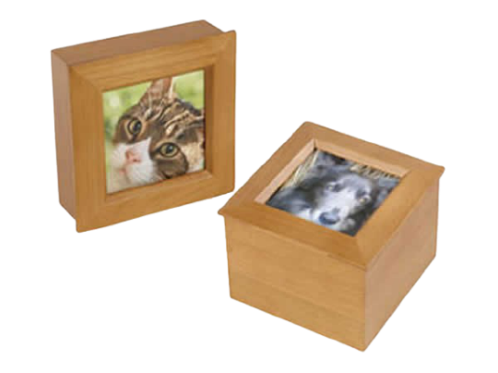**PET CASKETS**

**Tribute Box**

Beautifully crafted tribute box featuring a photo frame lid.

Cat/Rabbit £TBA please quote V34

Dog £TBA please quote V34

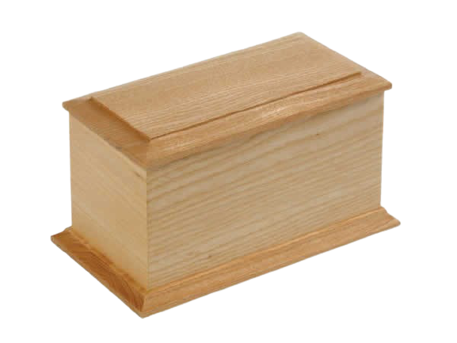**Natural Wood Casket**

This natural wood casket comes in various sizes and accommodates an engraved bronze name plaque.

Cat/ Rabbit £TBA please quote V05

Dog £TBA please quote V05